Report no. ETMS-TFMDI-002

Traffic Flow Management
Data to Industry:

Explanation of the Data

Version 1.0

10 August 2004

Prepared by

Volpe Center
55 Broadway
Cambridge, MA 02142
Table of Contents

1. Introduction 3
1.1. Background 3
1.2. Purpose of this Document 3
1.3. Use of the TFM Data 4
1.4. XML Tags 4
1.5. References 4
2. Public Reroutes and Flight Lists 6
2.1. Introduction 6
2.2. The Create Reroute Dialog Box 6
2.3. The Reroute Definition Tab 10
2.3.1. Introduction 10
2.3.2. Flight Identification Fields 10
2.3.3. Characteristics Fields 10
2.3.4. Route Information Fields: Filling in the Grids 11
2.3.5. Full Routes v. Split Routes 11
2.3.6. Filters 15
2.3.7. Miscellaneous Data About Reroute Segments 15
2.4. The Flight List Tab 19
2.5. The Advisory Tab 19
3. Public Flow Evaluation Areas/Flow Constrained Areas 21
4. Flow Evaluation Area/Flow Constrained Area Flight Lists 21
5. Alert Data 21
6. Collaborative Convective Forecast Product 21
7. National Convective Weather Forecast 21

Introduction

Background

Currently, the FAA provides a great deal of data to Collaborative Decision Making (CDM) participants on the Common Constraint Situation Display (CCSD). The CCSD, in effect, provides a map that graphically displays current information relevant to traffic flow management (TFM) such as flow evaluation areas (FEAs), flow constraint areas (FCAs), reroutes, and alerts. In addition, the CCSD provides textual data about these items, such as reroute advisories and lists of flights that are affected. This data is jointly referred to in this document as TFM data.

The distribution of this data on the CCSD has gone part of the way toward providing common situational awareness to NAS users, but there are two shortcomings.

- The data on the CCSD is “display-only” in that the user can, for example, see the FCA on the CCSD but does not have access in computer-readable format to the data that defines the FCA, e.g., the lat/lons of the corners. This means that the user cannot in an automated way grab this data and use it in internal applications.
- The data is not available even in display-only mode to the Aircraft Situation Display to Industry (ASDI) vendors, so these vendors are not able to include this data in any of the products that they supply to the aviation community.

To deal with these two shortcomings, the FAA has decided to undertake the program called TFM Data to Industry (TFMDI). In short, this program will provide the TFM data in a machine-readable format to Industry, which could then incorporate it into their tools. For example, if the data that defines an FCA (the lat/lon of the corners, upper and lower altitudes, filtering, and so forth) were provided, then Industry could incorporate FCAs into their own displays and other tools. This would improve the tools, promote common situational awareness, and perhaps provide this data to a much wider audience.

Purpose of this Document

A interface control document is being provided that gives detailed formatting information to industry users of the TFM data; see the reference in section 1.5. If, however, industry users are to make satisfactory use of this data, they need to know much more than how the data is formatted; that is, they need to know what the data means so that they can incorporate it into their applications in a meaningful and useful way. The purpose of this document is to provide additional understanding of this data. Since traffic flow management is both complicated and rapidly changing, it should not be expected that this document is a totally comprehensive guide to this data, but it will provide information that the industry user might not otherwise have ready access to.

The current version of this document only describes the data for public reroutes. As more types of TFM data become available, this document will be expanded to cover them.

Use of the TFM Data

It should be stressed that it is the responsibility of the Industry user how to learn the characteristics of the TFM data and to determine how to use it properly. It is not the responsibility of the FAA or Volpe to tell Industry how to use this data, to evaluate the industry products, or to attempt to exert any kind of quality control; it is up to the private sector to determine how the data should be used and to police the quality of the products.

In short, this document can be used as a source of information, but it is still up to industry to decide how to use the data.

There is, however, one point that industry developers might keep in mind, and that is the value of providing common situational awareness, which means not only that everyone is looking at the same data but also looking at it displayed in similar ways. The FAA views this data on the Traffic Situation Display, and much of industry currently views it on the Common Constraint Situation Display, which is patterned after the TSD. If industry tools look like the TSD and the CCSD, this will promote common situational awareness, so industry will want to consider the degree to which its display tools should look like these two FAA tools. Industry can see how this data is displayed on the CCSD by examining the screenshots and text in the CCSD user manual; see Section 1.5

XML Tags

The TFM data is for the most part provided in the XML language. A central feature of this language is that it marks each piece of data with what is called a tag. An example will make this clear. In a TFM data XML file one would see the aircraft ID as

<ACID>COA218</ACID>

<ACID> is the opening tag, and </ACID> is the closing tag. The data is between the two tags. This means that a program finds <ACID>, and it knows that everything that it finds until it reaches </ACID> represents the aircraft ID.

The interface control document (see Section 1.5) uses tags to describe the format of the document. So that the data referred to in this document can be related to the data in the ICD, the tags will be used here to indicate the data that is being discussed. The reader should consult the ICD not only for the formatting but also for the values than each tag might take; this document will not try to describe every value. The reader who is not interested in the formatting but only wants to learn about the data can ignore these tags in this document.

References

“Traffic Flow Management Data to Industry: Overview,” Volpe Center, report no. ETMS-TFMDI-001, ver. 1.0, 10 August 2004. This document explains the rationale for the TFM Data to Industry program and spells out the principles that guide it.

“Traffic Flow Management Data to Industry: Interface Control Document,” Volpe Center, report no. ETMS-TFMDI-003, ver. 1.0, 10 August 2004. This document provides detailed information, e.g., formatting and allowed values, that is needed by software developers who are writing applications that make use of the TFM data. This document is referred to as the ICD.

To download the latest versions of the documents listed here as well as others such as sample data files, go to the Traffic Flow Management Data to Industry web page at http://www.fly.faa.gov/ASDI/asdi.html

For access to the coded departure routes, see http://www.fly.faa.gov/Products/Coded_Departure_Routes/coded_departure_routes.html

To download the National Playbook, go to http://www.fly.faa.gov/ois/

To download the CCSD user manual, go to http://www.metronaviation.com/cdm/products/ccsd.html

Public Reroutes and Flight Lists

Introduction

The ideal is that every National Airspace System (NAS) user files the route that it wants to fly, and it then flies that route. It might be the case, however, that congestion in the NAS prevents the NAS user from flying the route that it wants to fly. This congestion might arise because of bad weather, extremely heavy traffic, a failed navaid, or any number of other reasons. If this congestion is of more than local significance, then the severe weather specialists at the Air Traffic Control System Command Center (ATCSCC, or Command Center for short) might issue a public reroute. The essence of a public reroute is that it specifies which flights are affected and which reroutes they should take. The reason why a public reroute is issued is to organize the system’s response to the congestion so that it will be dealt with in an efficient and equitable way.

The Traffic Situation Display (TSD) is the main user interface to ETMS; it shows aviation activity graphically, and it also provides a number of tools. One of these tools is the Create Reroute dialog box. A severe weather specialist at the Command Center uses this dialog box to define and issue a public reroute.

The expositional strategy followed in this section is to let the reader look over the shoulder of a severe weather specialist as he or she uses the Create Reroute dialog box to define a public reroute and then issue an advisory; this shows how the public reroute data is generated. The hope is that showing how the public reroute data arises from the actions of a severe weather specialist will help the reader to understand this data. The goal is to put the Industry reader in a position to make good use of this data.

The Create Reroute Dialog Box

When the severe weather specialist issues the TSD’s Create Reroute command, he or she will then see the Create Reroute dialog box as shown in Figure 2-1. It is seen that this dialog box has three tabs, and it opens on the “Reroute Definition” tab, which is used to provide the basic information about the reroute. If the specialist clicks the “Flight List” tab, then the user sees the blank flight list shown in Figure 2-2; this list, when filled in, shows the flights affected by the reroute. Finally, if the specialist clicks the “Advisory” tab, then the user sees the template in Figure 2-3 that is filled in to produce the text that goes into the public reroute advisory. The information from these three tabs is included in the TFM Data to Industry. The discussion below is organized by these three tabs.

Once the severe weather specialist has filled out all three tabs as desired, he or she clicks the “Send” button at the bottom of the dialog box, and this causes the public reroute advisory to be sent to NAS users and FAA facilities, who then have the responsibility of implementing this advisory, i.e., of seeing that the designated aircraft fly the specified reroutes; this implementation is beyond the scope of this document and will not be discussed further here.

Note: Fields in this dialog box that are marked with an asterisk are required fields that the severe weather specialist must fill in. Also, this document is not a tutorial on how to use the Create Reroute
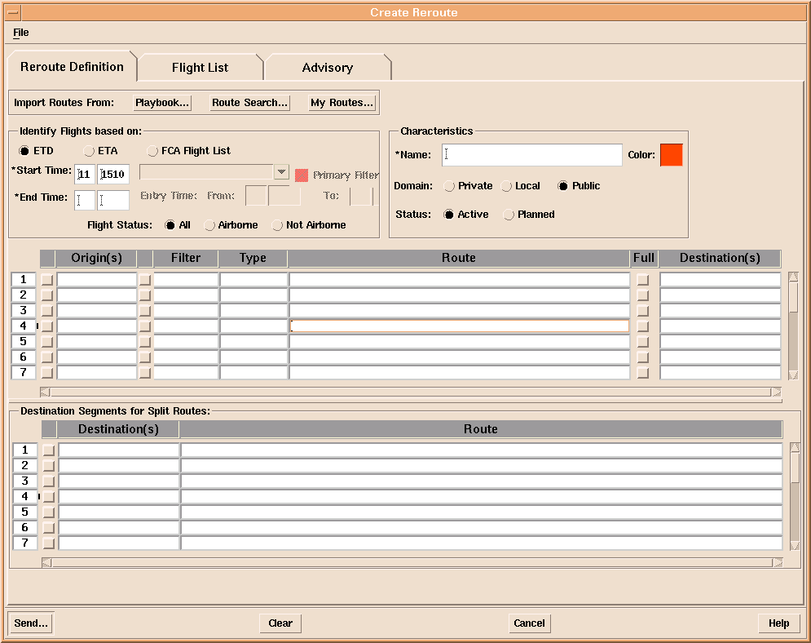

Figure 2-1: Create Reroute Dialog Box: Reroute Definition Tab
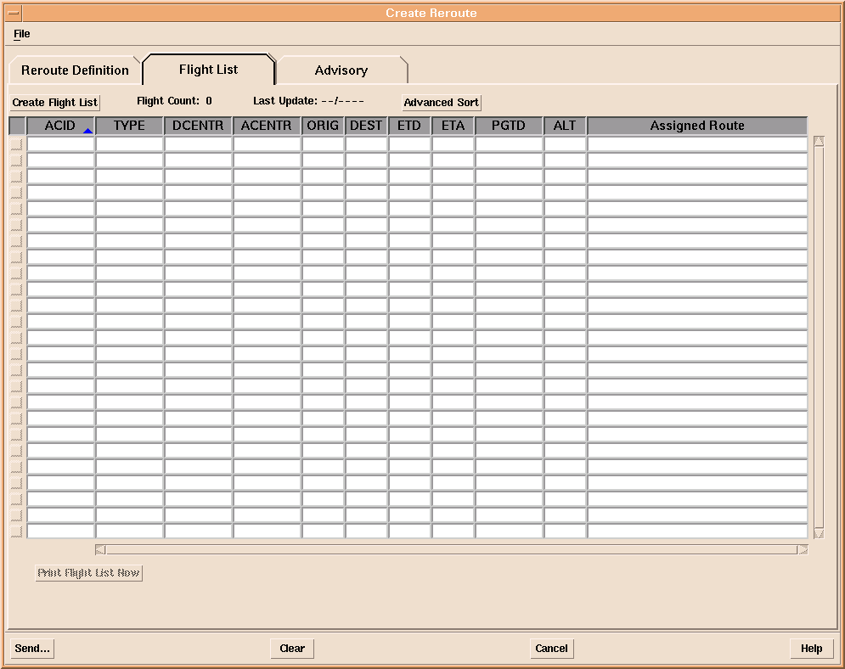

Figure 2-2: Create Reroute Dialog Box: Flight List Tab
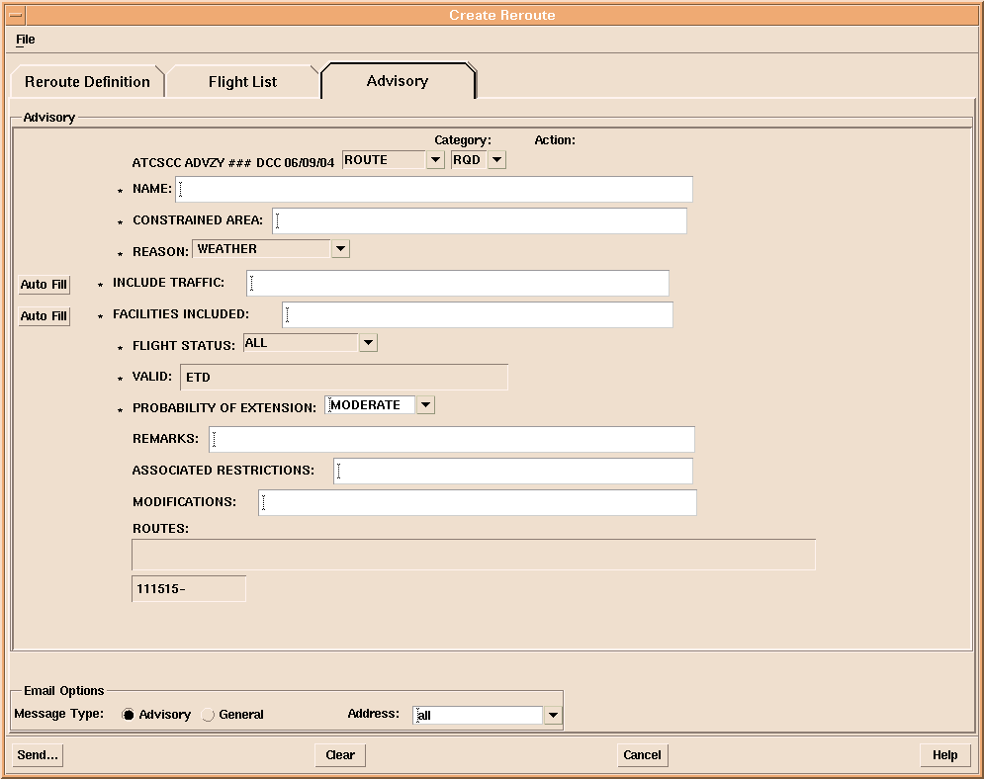

Figure 2-3: Create Reroute Dialog Box: Advisory Tab
dialog box; aspects of this dialog box that do not affect the TFM data provided to Industry, e.g., the options to sort the order in which flights are displayed in the flight list, are not discussed here.

The Reroute Definition Tab

Introduction

The severe weather specialist uses the Reroute Definition tab to specify the details of the flights that are subject to the reroute and also to specify the reroutes that they should take. Each area of this tab will be explained. To get the most out of this discussion, the user should relate the text below to the picture of the Reroute Definition tab in Figure 2-1. As explained above, the tags are shown so that the reader can relate the discussion here to the fields shown in the ICD. A reader not interested in details of programming can skip the tags.

Flight Identification Fields

The first item is to indicate the start time <REROUTE_STARTTIME> and stop time <REROUTE_ENDTIME> of the reroute. There are three possible interpretations of these times; which interpretation is being used in indicated by <REROUTE_TIMETYPE>. The first interpretation is that a flight is covered by this reroute if its actual or predicted wheels-up time is between the start time and the stop time. The second interpretation is that a flight is covered by this reroute if its predicted wheels-down time is between the start time and the stop time.

The third interpretation is a little more involved. The severe weather specialist might indicate that this reroute is based on a flow-constrained area (FCA). An FCA is a designated volume of airspace that is relevant to the reroute; for example, an FCA might be airspace that surrounds convective weather. The goal might be for flights that intersect an FCA to be rerouted out of the FCA. For a fuller description of FCAs, see section 3 (to be provided in a later version of this document). If the severe weather specialist indicates that an FCA is to be used as the basis for this reroute, then the name of the FCA <FCA_NAME> is included in the TFM data; the start <FCA_STARTTIME> and stop <FCA_ENDTIME> times are taken from the definition of the FCA; these cannot be changed within the Create Reroute dialog box.

The severe weather specialist must also indicate which flights <AIRBORNE> are included in the reroute, where the choices are to include only flights that are airborne when the reroute is issued, only the flights that are not yet airborne when the reroute is issued, or all flights.

Characteristics Fields

The severe weather specialist gives each public reroute a name <NAME> that uniquely identifies it. The domain <DOMAIN> will always be public for reroutes that appear in the TFM data; the other categories are for internal FAA use. The status <STATUS> can be active, which means that this reroute is effective and should be taken into account in all decisions, or planned, which means that this is not currently an active reroute but that it might eventually become one; users can take the possibility that it will become an active reroute into account in their planning.

Route Information Fields: Filling in the Grids

At the heart of the Create Reroute dialog box are the grids in Figure 2-1, which are used to indicate the reroutes and the flights that must take each reroute. While a severe weather specialist could fill in these grids by typing in by hand all the reroute information, this is time-consuming and rarely done. Quicker ways of entering the data automatically are:

- Load in one or more plays from the National Playbook.
- Load in one or more coded departure routes.
- Load in one or more routes that the specialist has used in the past and has saved.

The National Playbook and coded departure routes will not be discussed any further here since, from the point of view of the TFM data, what matters is the data itself rather than its source. If the reader wants to investigate the National Playbook or the coded departure routes further, see the web sites referred to in Section 1.5. However the specialist initially enters the data, he or she will need to fine tune it so that it fits the particular situation being handled; the next few sections indicate how does this fine tuning is done and how it is represented in the TFM data.

Full Routes v. Split Routes

The data in any one line of the grids in the Create Reroute dialog box is called a reroute segment. A reroute segment might be a full route or a split route. Understanding the difference between a full route and a split route is critical to understanding the TFM reroute data.

Figure 2-4 shows three coded departure routes that have been loaded into the Create Reroute dialog box to illustrate a full route. This figure shows three reroutes from LGA <ORIGIN> to BOS <DESTINATION>. Since three routes are given with no filtering, this means that any of the flights from LGA to BOS will be compliant with the reroute if it takes any of these three routes. These are called full routes since the reroute for a city pair consists of a single string of elements on one line. In this case, the full route goes all the way from origin to destination, but this is not always the case.

In Figure 2-5 the BAE_2 play from the National Playbook has been loaded into the Create Reroute dialog box to illustrate a split reroute. It is seen that the fix BAE is the last element in the origin segments in the top grid and also the first element in the destination segments in the bottom grid. For example, for a flight going from MSP in ZMP to JFK, the required route is MCW J16 BAE J70 LVZ LENDY5; any flight from MSP to JFK that includes this route segment in its flight plan is compliant with the reroute advisory. It is seen that by combining the origin route segment with the destination route segment, where BAE is the point where they join, a reroute is constructed. The BAE_2 play is shown graphically in Figure 2-6.

A reroute such as is shown in Figure 2-5 is called a split route since any origin segment in the top grid can be combined with any destination segment in the bottom grid. Put another way, the origin segments fan in to a common point, and the destination segments then fan out from this common point. Not all split routes, however, are as simple as this example since sometimes not all route segments will fan into and out of a single point. Split routes can have more than one common point, so it will not be the case that all of the origin segments will match all of the destination segments; in this case, the route needs to be formed by matching the last point in some origin segment with the first point in some destination segment.

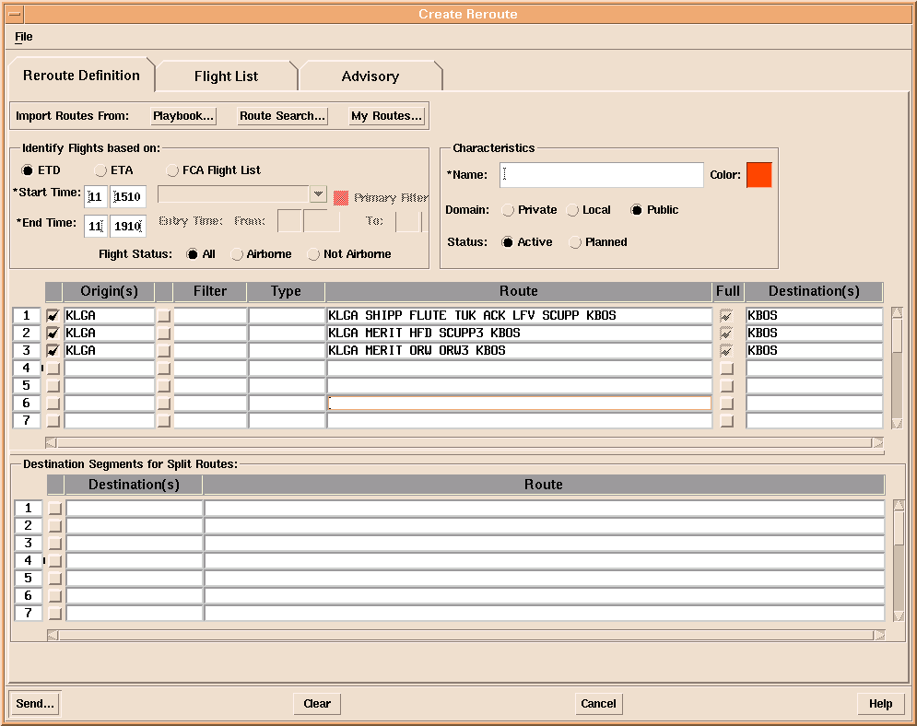

Figure 2-4: Example of Full Routes
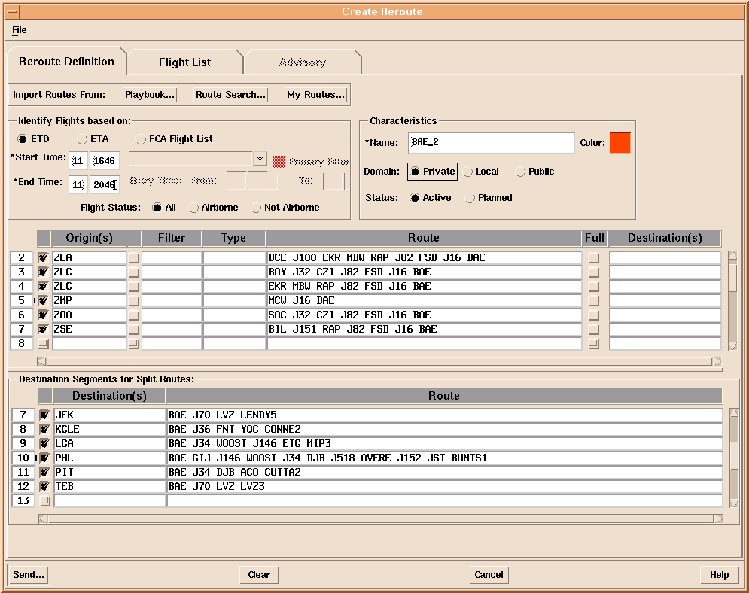

Figure 2-5: Example of Split Routes
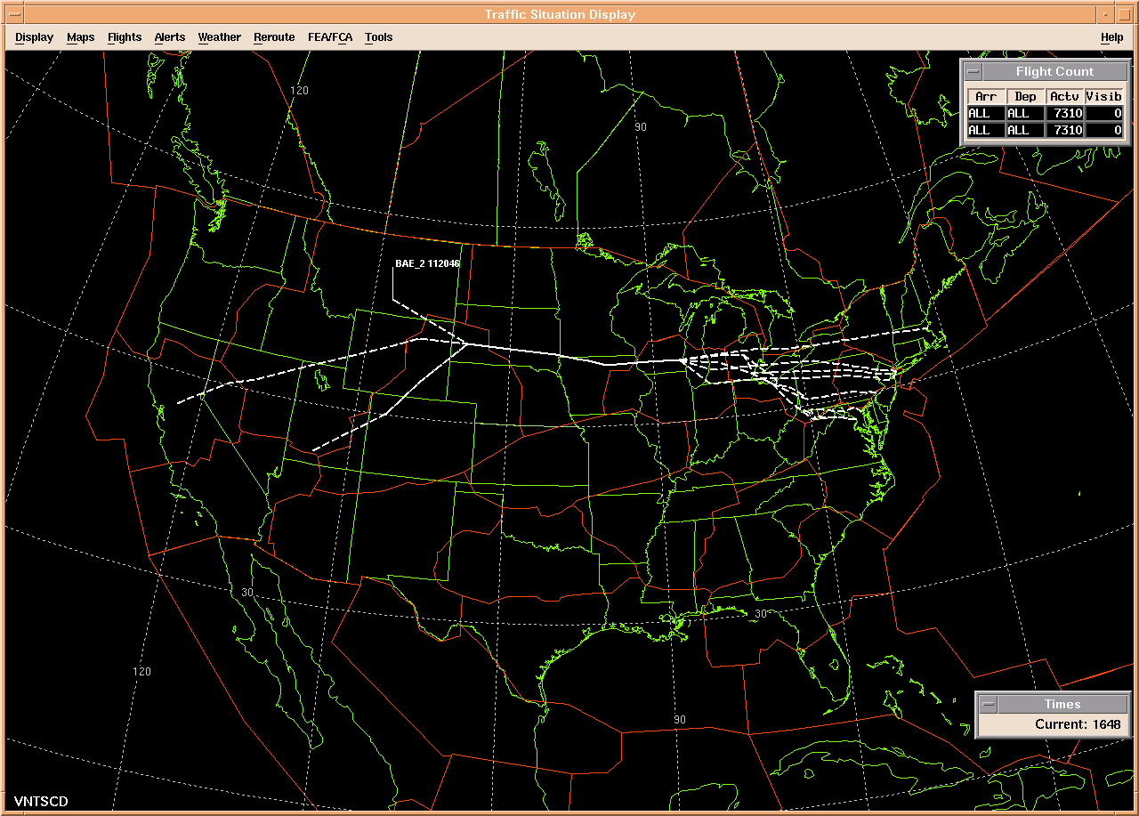

Figure 2-6: Example Split Routes Displayed on the TSD
Whether a reroute segment is a full route or part of a split route is indicated by the <FULL_ROUTE> tag, wbich has three possible values.

- FULL: Indicates that the reroute segment is a full route.
- ORIG: Indicates that the reroute segment is a origin segment in a split route.
- DEST: Indicates that the reroute segment is a destination segment in a split route.

For any of these values, <ROUTE_STR> gives the text of the reroute segment in the Route column of Figure 2-5.

Filters

If the severe weather specialist clicks the button just to the left of the filter field, then the Flight Filters dialog box pops up; this is shown in Figure 2-7. This allows the severe weather specialist to limit the reroute segment to a particular flight set. For example, if in the first line of the play shown in Figure 2-5 the severe weather specialist wants to exempt all flights departing from LAX, he or she enters LAX into the “do not depart from” fields in the Flight Filters box in Figure 2-7, clicks OK, and this filters the first reroute segment to exclude flights departing from LAX, as shown in Figure 2-8.

The tag <CTR_FLTR> includes all the filter tags; see the ICD for details. A text summary <FLTR_SUMMARY> describes the filters for a reroute segment; in Figure 2-8 this text is “-LAX”. This text is redundant, but it is included to provide a human-readable description of the filters.

Miscellaneous Data About Reroute Segments

The severe weather specialist can choose to include or exclude any of the route segments shown in the Create Reroute dialog box; this is done by checking or unchecking the box at the left of the reroute segment. For example, in Figure 2-8 the flights originating from ZSE are excluded from the reroute. From the industry user’s point of view, any reroute segments that are excluded are not part of the reroute and can be ignored. The <INCLUDE> tag indicates if a reroute segment is included.

The severe weather specialist can fill in the Type field <ROUTE_TYPE> in Figure 2-6 with one of the following values.

- NONE
- CDR RTE
- RERTE
- UNKN RTE
- UPT RTE

If the Type is NONE, ETMS parses the route and includes waypoints <WAYPOINT> in the TFM data; this allows the route to be displayed. If the Type takes on any value other than NONE, ETMS does not parse the route and does not include waypoints in the data; the route is treated as an uninterpreted text string. UPT RTE, which stands for a user-preferred trajectory, means that the specialist does not specify a route; the NAS user is left to pick any route that avoids the FCA and that complies with any other conditions that are specified, e.g., that the route go north of a given fix.

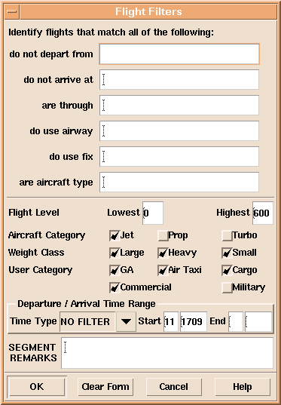

Figure 2-7: Flight Filters Dialog Box
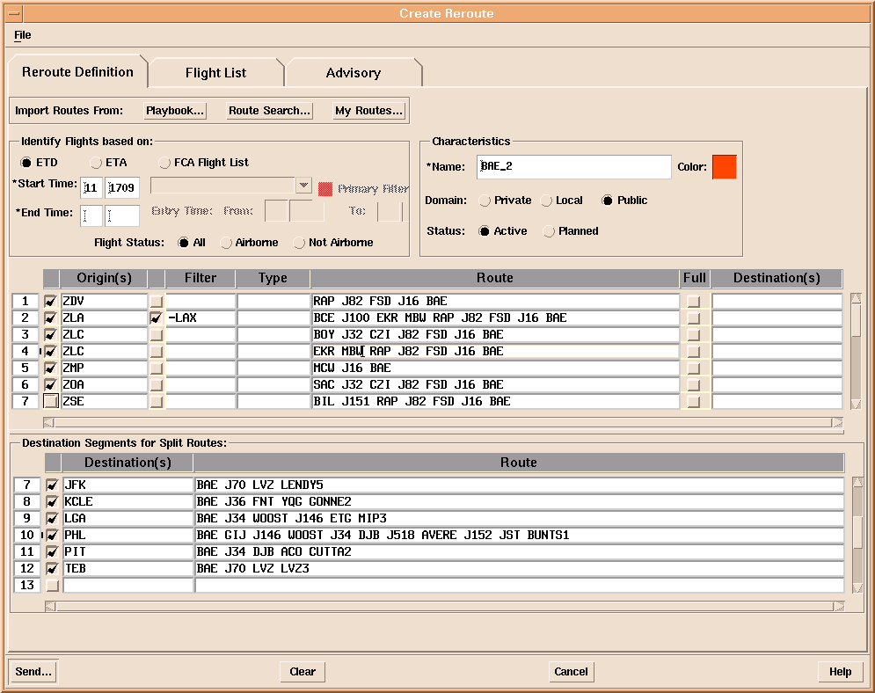

Figure 2-8: Example of a Filtered Route
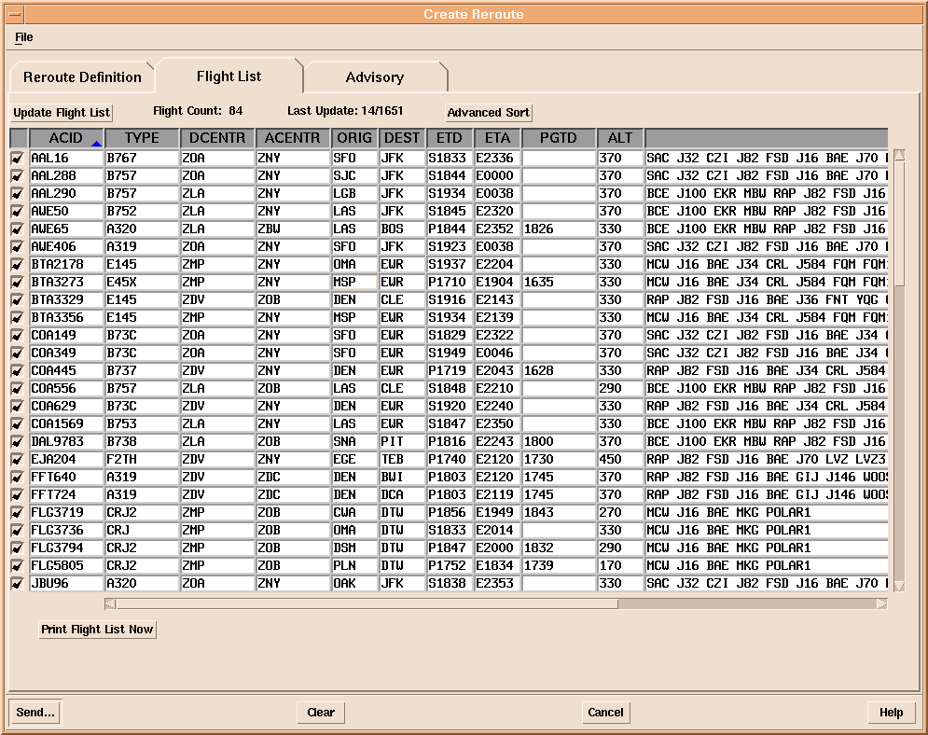

Figure 2-9: Example of a Flight List

If in the Flight Filters dialog box in Figure 2-7 the severe weather specialist entered any text in the “Segment Remarks” field, these are included in <SEG_REMARKS>. This text can be thought of as a comment.

The Flight List Tab

Once the severe weather specialist has filled out the Reroute Definition tab in the Create Reroute dialog box, he or she will probably next want to see the list of flights that are affected by this reroute. The severe weather specialist can then click the Flight List tab to go to the empty flight list shown in Figure 2-2. If the severe weather specialist clicks the “Update Flight List” button, ETMS determines which flights known to the system satisfy the criteria spelled out in the Reroute Definition tab, and it then displays the list. Figure 2-9 shows the flight list that was calculated for the BAE_2 play.

The severe weather specialist can inspect the flights to make sure that these are indeed the flights that should be rerouted. If the specialist determines that this flight list needs to be adjusted, he or she can go back to the Reroute Definition tab, modify the definition of the reroute, return to the Flight List tab, and update the flight list. Also, if the specialist determines that a particular flight in the list should not be included in the reroute, this flight can excluded by unchecking the box at the far left of the line of data for this flight in the Flight List; whether a flight is include or excluded from the reroute is indicated in the tag <INCLUDE_RTE>.

Most advisories will have a flight list. If there is no flight list, then the container tag <CTR_FLIGHT_LIST> will not be present.

The Advisory Tab

Once the severe weather specialist is satisfied with the reroute definitions and with the flight list, it is time to click the “Advisory” tab and to complete the text of the advisory. The specialist needs to select a category <CATEGORY>, where the possible values in the pick list currently are:

- CDR
- FCA
- INFO
- MISC
- NAT
- NRP
- PLAYBOOK
- ROUTE
- SHUTTLE
- SPECOPS
- VACAPES

New categories might be added in the future. The specialist also indicates the Action <ACTION>, where the possible values in the pick list currently are:

- FYI: This advisory is for informational purposes only. No action is required from the NAS users.
- PLN: This indicates a reroute that might be issued in the future (or might not, depending on the course of events). No action is required from the NAS users, but they can take this possible reroute into account in their planning if they wish.
- RMD: This indicates reroutes that are recommend but not required. No action is required from the NAS users, but they should consider the reroutes specified in the advisory.
- RQD: This advisory is required. All affected flights are expected to comply with it.

New actions might be added in the future.

Once the specialist has filled out the rest of the fields in the advisory tab and is content with all the data shown in all the tabs, the specialist clicks Send, and this distributes the advisory to the NAS users and to FAA facilities. At this point the public reroute data becomes available in the TFM Data to Industry feed.

Public Flow Evaluation Areas/Flow Constrained Areas

To be provided later.

Flow Evaluation Area/Flow Constrained Area Flight Lists

To be provided later.

Alert Data

To be provide later.

Collaborative Convective Forecast Product

To be provided later.

National Convective Weather Forecast

To be provided later.

